Mingyue Liang
EAP II: Academic Writing in the U.S.
Professor: Prof. Zehala
Date of Submission: February 16th
Project 1.1

The Power of Language: Finding My Voice in a New World

Language is more than just a way to talk to people -- to me, it shapes who we are and how others perceive us. In “Mother Tongue,” Amy Tan talks about how her mother’s English made people judge her unfairly, which influenced how Tan saw language. Similarly, in “The Power of Nostalgia,” Cheyne Gallarde explains how memories can guide us through life. I have had my own moments when I realized just how powerful language is, like when I felt invisible in a class discussion, struggled to fit in socially, and missed the comfort of speaking my native language. It was an extremely isolating experience, even as far as to say that it was one of many adversities in life. In my experience, it showed me that language can either hold us back or help us move forward; I could have chose to give up or continue pursuing.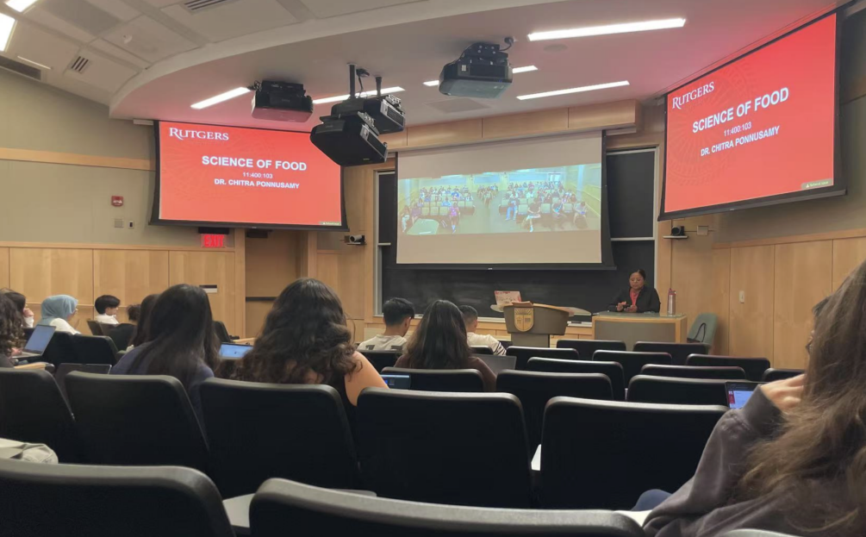
A few months ago when I was in my Women and Leadership class, we had a small group discussion on gender equality. I was excited because I had read a lot about the topic in my native language, but when it was time to talk, I could not find the right words in English. I was extremely passionate on the topic and I knew what I wanted to say, but my sentences felt messy, and I struggled to keep up. I felt a sense of shame and in a way, it was me censoring myself. When the professor asked each group to pick someone to share their ideas, one of my group members turned to the other girl and asked if she wanted to do it -- she did not even look at me. In that moment, I felt like my opinions did not matter, as if my voice was not even a part of the conversation and that no one cared for what I had to say. That is when I realized that in this academic world, being able to express yourself clearly in English meant being heard and respected. I began to wonder if my classmates assumed I did not have valuable ideas just because I struggled with words. Amy Tan had a similar experience growing up. She reflects, “I know this for a fact, because when I was growing up, my mother’s ‘limited’ English limited my perception of her” (Tan, p. 2). Just as Tan once misunderstood her mother’s intelligence due to her English, I started questioning whether others judged my abilities based on how I spoke rather than what I had to say. That experience changed how I saw learning English. Before, I studied it because I had to -- now, I wanted to. I did not want to be ignored again. I started paying more attention to academic words, especially ones related to gender studies, so I could participate better in class discussions. I watched TED Talks and read articles in English, not just for class, but to really understand how people expressed complex ideas. Amy Tan also changed how she saw language. She once tried to prove she had mastered English by writing overly complicated sentences. Eventually, she realized that true mastery was not about sounding impressive, it was about communicating clearly. She says, “I began to write stories using all the Englishes I grew up with” (Tan). That made me relaize that I did not have to abandon my first language to get better at English. This shows that I can continue to improve my English while keeping my native language an important part of who I am.
Being away from home also made me realize how much language connects to my emotions. Every year, my family celebrates Chinese New Year together—we make dumplings, eat a big meal, and my relatives give me red envelopes。It is a holiday I held dear to my heart. Sadly this year, I spent the holiday alone -- no family, no dumplings, no red envelopes. It hit me how much I missed home. Cheyne Gallarde talks about how memories can be a “compass” that guides us. He says, “We have all these objects, things, music, books, places, memories that we hold onto. And we should be able to reflect on them fondly” (Gallarde 03:15). Gallarde emphasizes how these personal objects and experiences can shape our indentity much like his jacket represents a part of his story, for me my native language is that compass. Whenever I feel lost or disconnected, speaking or hearing my first language reminds me where I come from and gives me strength. My family wants me to succeed in an English-speaking world, but that does not mean I have to forget my roots.
Language isn’t just about words but also about culture. One day, my friend told me that some people in my dorm thought I was ‘cold’ and distant. I was shocked. Back home, I was always seen as friendly and warm. Here in the U.S., people have different ways of showing friendliness. This reminded me of how Tan’s mother was judged for her English often being perceived as unintelligent and not taken seriously. Tan writes, “Some say they understand none of it, as if she were speaking a completyely different language” (Tan). Like her mother, I was not actually cold-my way of interacting was just different. After that, I started watching how my American classmates socialized, and I adjusted a little while still being myself.
Looking back, I see how much my perspective on language has changed. At first, I felt like my English skills limited me. Now, I see language as a bridge that connects me to new opportunities and people. Amy Tan learned to embrace all the versions of English she grew up with, and that inspires me to do the same. Upon hearing others perspectives I learned to understand that while I’m building a future in a new place, my cultural roots will always be with me. Learning English is not just about grammar and vocabulary -- it is about finding my voice in this new world while holding on to the one I came from.

